Back

Module 1 Quiz

Quiz, 10 questions

Question 1

1

point

**1. Question 1**

Select the option that correctly completes the sentence:

Training a model using labeled data and using this model to predict the labels for new data is known as ____________.



Clustering



Unsupervised Learning



Supervised Learning



Density Estimation

Question 2

1

point

**2. Question 2**

Select the option that correctly completes the sentence:

Modeling the features of an unlabeled dataset to find hidden structure is known as ____________.



Unsupervised Learning



Supervised Learning



Classification



Regression

Question 3

1

point

**3. Question 3**

Select the option that correctly completes the sentence:

Training a model using categorically labelled data to predict labels for new data is known as __________.



Regression



Clustering



Feature Extraction



Classification

Question 4

1

point

**4. Question 4**

Select the option that correctly completes the sentence:

Training a model using labelled data where the labels are continuous quantities to predict labels for new data is known as __________.



Feature Extraction



Clustering



Classification



Regression

Question 5

1

point

**5. Question 5**

Using the data for classes 0, 1, and 2 plotted below, what class would a KNeighborsClassifier classify the new point as for k = 1 and k = 3?

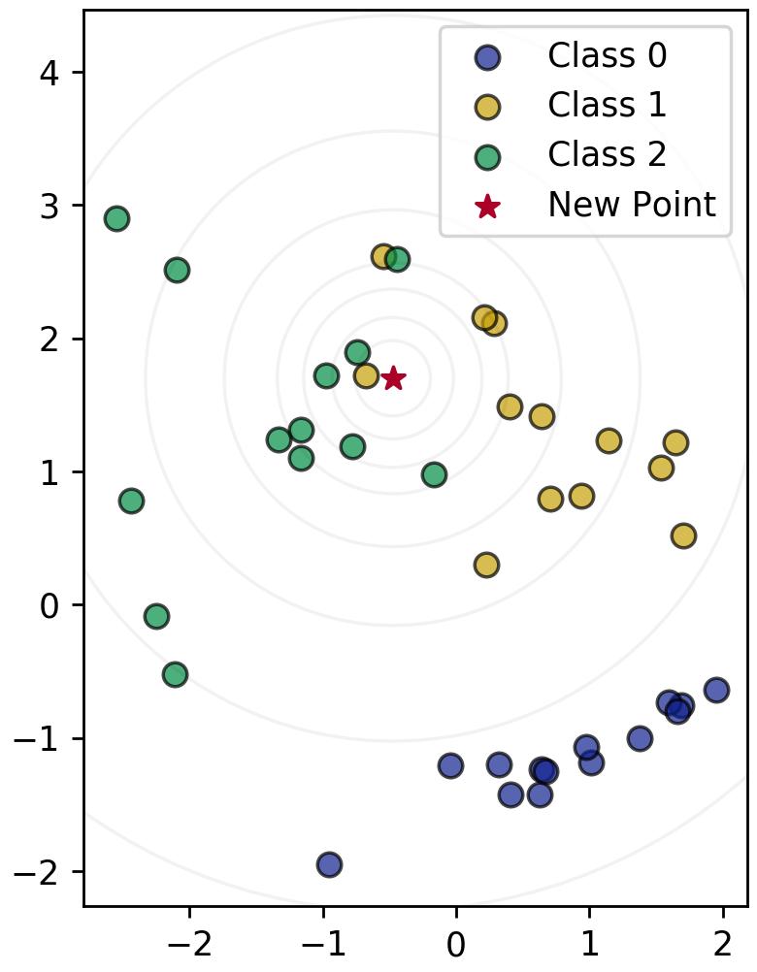



* k=1: Class 1
* k=3: Class 2



* k=1: Class 0
* k=3: Class 2



* k=1: Class 2
* k=3: Class 1



* k=1: Class 0
* k=3: Class 1



* k=1: Class 1
* k=3: Class 0

Question 6

1

point

**6. Question 6**

Which of the following is true for the nearest neighbor classifier (Select all that apply):



A higher value of k leads to a more complex decision boundary



Given a data instance to classify, computes the probability of each possible class using a statistical model of the input features



Memorizes the entire training set



Partitions observations into k clusters where each observation belongs to the cluster with the nearest mean

Question 7

1

point

**7. Question 7**

Why is it important to examine your dataset as a first step in applying machine learning? (Select all that apply):



See what type of cleaning or preprocessing still needs to be done



You might notice missing data



Gain insight on what machine learning model might be appropriate, if any



Get a sense for how difficult the problem might be



It is not important

Question 8

1

point

**8. Question 8**

The key purpose of splitting the dataset into training and test sets is:



To speed up the training process



To reduce the number of features we need to consider as input to the learning algorithm



To estimate how well the learned model will generalize to new data



To reduce the amount of labelled data needed for evaluating classifier accuracy

Question 9

1

point

**9. Question 9**

The purpose of setting the random_state parameter in train_test_split is: (Select all that apply)



To avoid bias in data splitting



To make experiments easily reproducible by always using the same partitioning of the data



To split the data into similar subsets so that bias is not introduced into the final results



To avoid predictable splitting of the data

Question 10

1

point

**10. Question 10**

Given a dataset with 10,000 observations and 50 features plus one label, what would be the dimensions of X_train, y_train, X_test, and y_test? Assume a train/test split of 75%/25%.



* X_train: (10000, 28)
* y_train: (10000, )
* X_test: (10000, 12)
* y_test: (10000, )



* X_train: (7500, 50)
* y_train: (7500, )
* X_test: (2500, 50)
* y_test: (2500, )



* X_train: (2500, )
* y_train: (2500, 50)
* X_test: (7500, )
* y_test: (7500, 50)



* X_train: (2500, 50)
* y_train: (2500, )
* X_test: (7500, 50)
* y_test: (7500, )



* X_train: (10000, 50)
* y_train: (10000, )
* X_test: (10000, 50)
* y_test: (10000, )